**Sales performance Analysis**

**Excel Dashboard**

Raja Israr Azam Kiani

2024

**Introduction**

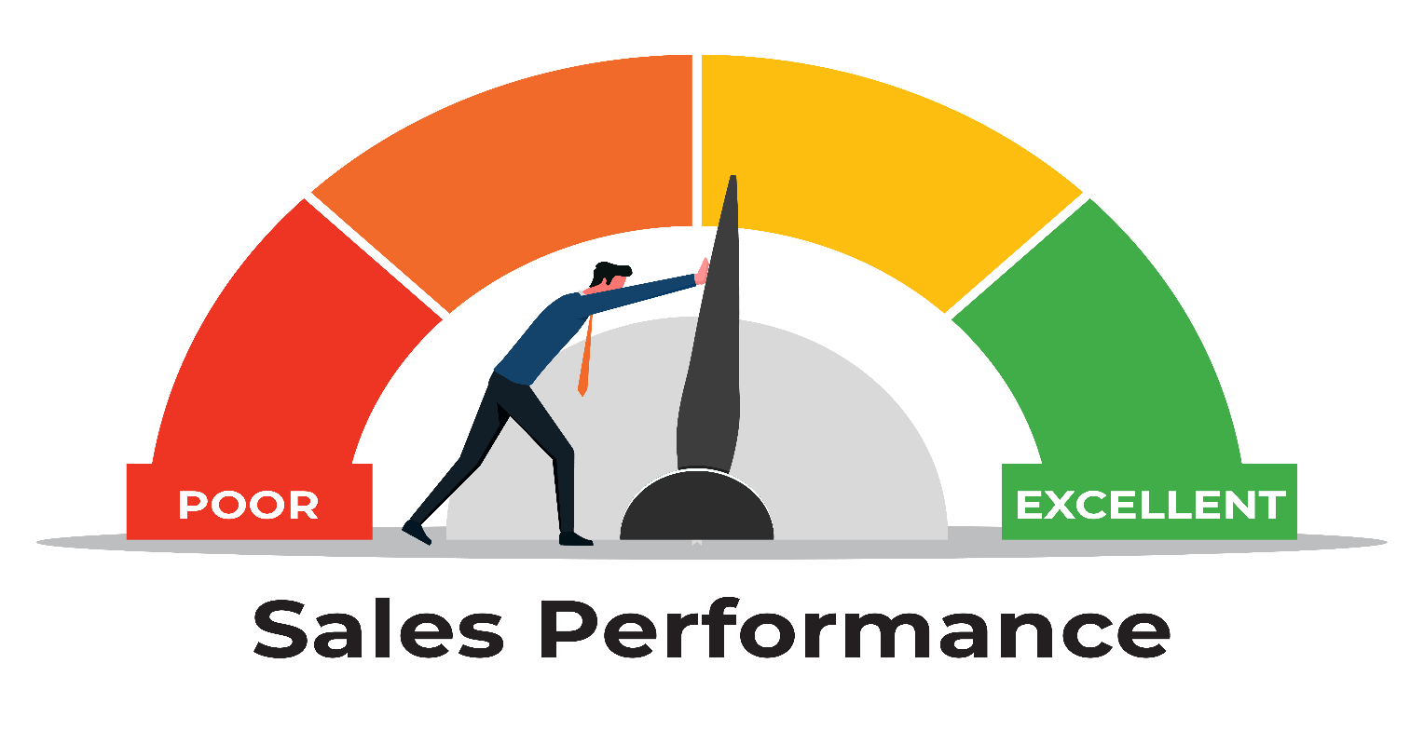Businesses greatly depend on precise and timely information to make decisions in the data-driven world of today. The task of combining massive amounts of sales data to monitor performance, spot trends, and inform strategic choices presents a challenge for Moiz, who recently launched his own business. Moiz likes to use Excel to develop an extensive sales performance dashboard because he doesn't know much about complex tech stacks. This dashboard makes use of Excel's features to help with data-driven decision-making and to deliver insights in real time.

**Business Problem**

The volume of sales data gathered from different items, salespersons, and time periods overwhelms Moiz as a new business owner. It is hard for him to track and analyze this data effectively without a centralized, interactive reporting platform. Due to this, chances to recognize important trends and make wise strategic choices have been lost, which is detrimental to the company's ability to expand and compete.

**Objectives**

The primary objectives of the sales performance dashboard are to:

1. Centralize sales data for easy access and analysis.
2. Provide real-time insights into sales performance.
3. Identify key trends and patterns to inform strategic decisions.
4. Improve the efficiency of the sales reporting process.

**Dataset Snapshot**

Below is a snapshot of the dataset used for the dashboard:

* Date
* Salesperson
* Region
* Product Category
* Product Sub-Category
* Units Sold
* Unit Price
* Total Sales (Units Sold * Unit Price)
* Customer Satisfaction Rating

**Key Metrics**

The dashboard tracks the following key metrics:

* **Total Sales:** The total revenue generated within a specific period.
* **Total Unit Sold:** The total unit sold within a specific period.
* **Average Unit Price:** Average of unit price within a specific period.
* **Total Profit:** The total profit generated within a specific period.
* **Salespersons by Sales:** Bar-graph to show top 5 salespersons by sale.
* **Product by Sales:** Bar-graph to show products by total sale.
* **Subcategory by Unit sales:** **:** Bar-graph to show subcategory of products by total sale.
* **Regional Sales Distribution:** Live Map-chart highlights regional sales distribution .
* **Sales Performance by Quarter:** Bar-chart shows sales performance quarter wise in a year.
* **Sales trends analysis:** Line chart to show sales trends analysis.
* **Salesperson Performance Metrics:** A table which highlight the key metrices of all salespersons with conditional formatting.
* **Pivot Tables:** Pivot Tables for the summary of and for chart creation.
* **Slicers:** To filter out data for more than one graph based on specific conditions like region, year, segment etc.

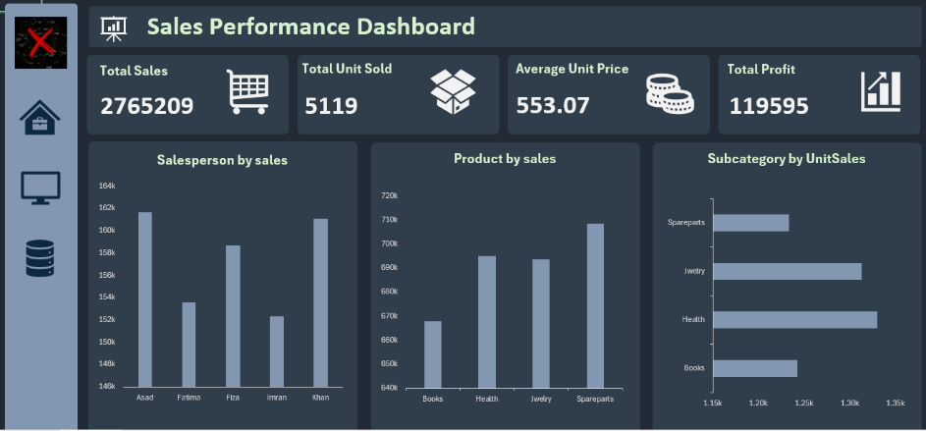

**Main Dashboard**

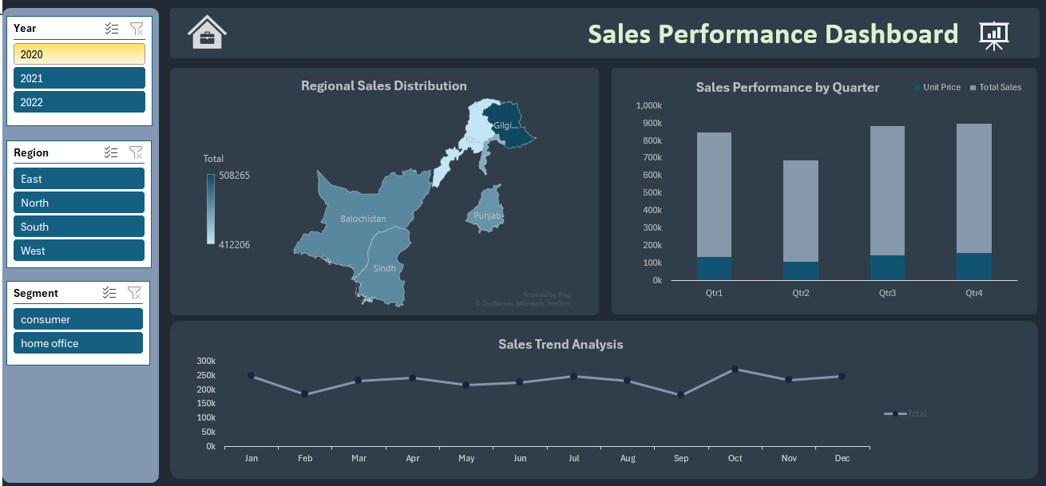

**2nd Dashboard**

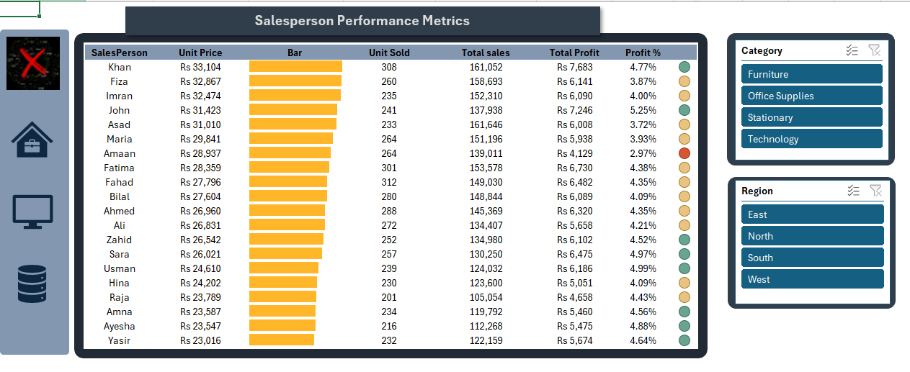

**Conditional Formatting Dashboard**

**Data Preprocessing**

The data was collected main database contain various records. The preprocessing steps to filter out our required data included:

* **Removing Duplicates**: Ensuring data accuracy by eliminating duplicate records.
* **Handling Missing Values:** Using appropriate imputation techniques to fill in missing data.
* **Standardizing Data Formats:** Ensuring consistency across the dataset for accurate analysis.
* **Data types**: Used appropriate data types like numbers, text, date ,geography etc.
* **New Columns**: Addition of new columns like total sales and percentage profit of salesman(in pivot).

**Dashboard Components and Features**

The sales performance dashboard includes the following components and features:

* **PivotTables and Pivot Charts:** Used to summarize and visualize data dynamically, allowing Moiz to drill down into specific details.
* **Interactive Controls:** Slicers enable Moiz to filter data by different dimensions, such as time period, region, or product category.
* **Visuals**: Visual Elements Bar charts, line graphs, and KPI indicators effectively represent the data, making it easy to identify trends and patterns.
* **Data Highlights:** Conditional formatting is used to highlight key metrics and performance indicators.
* **Dashboard Menu:** A menu with icons has been created to facilitate switching between different dashboards. This menu provides a user-friendly interface, allowing Moiz to quickly navigate between various dashboards, enhancing the overall usability and efficiency of the reporting tool.

**Challenges and Solutions**

During the development of the dashboard, several challenges were encountered:

**Map-Chart:** Using Map-Chart in Excel presented significant challenges, particularly when visualizing Punjab, Pakistan, as opposed to Punjab, India. Even after applying latitude and longitude, the problem persisted.

**User Experience:** Ensuring the dashboard was user-friendly and intuitive required multiple iterations and feedback sessions(with friends/seniors). This resulted in a design that meets Moiz’s needs as a new business owner.

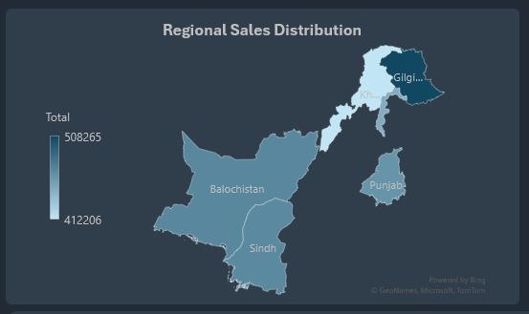

**Map Issue**

**Conclusion**

Moiz can monitor and spot patterns by using the sales performance dashboard, which gives him insightful data on important indicators. Better decision-making and strategic planning are now possible because to the dashboard's centralized, interactive design, which has increased the effectiveness of the sales reporting process.

**Recommendations**

To further enhance the dashboard and its utility, the following recommendations are proposed:

* **Future Enhancements:** Consider integrating real-time data updates to provide up-to-the-minute insights.
* **Additional Metrics:** Extend the dashboard to incorporate more metrics, including campaign results or customer satisfaction ratings.
* **Training:** Provide training sessions to help Moiz and his team maximize the use of the dashboard and its features.

Through the implementation of these ideas, Moiz's organization may sustain its competitive advantage in the market and foster growth by utilizing data-driven insights.